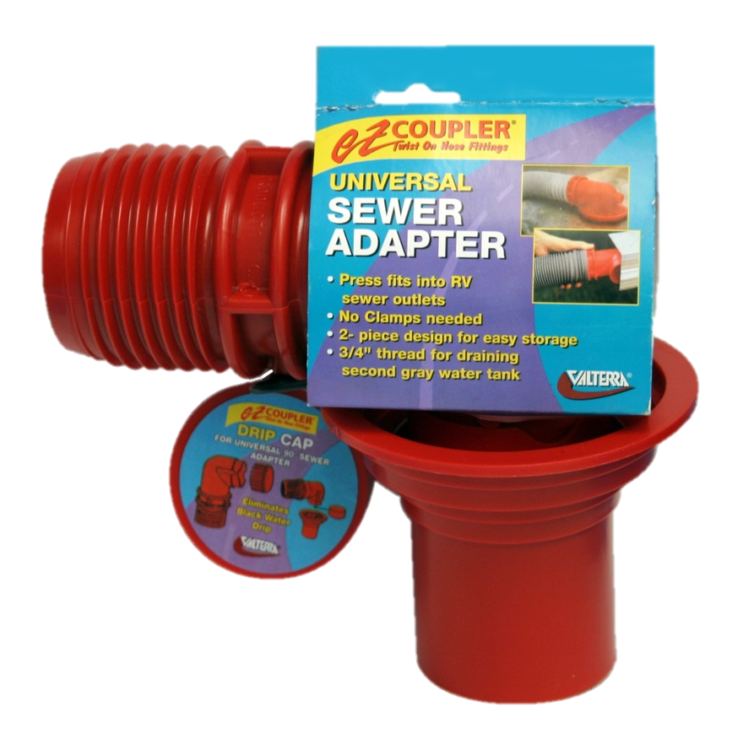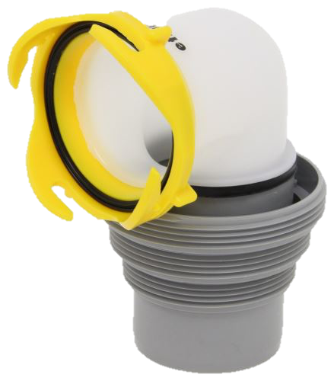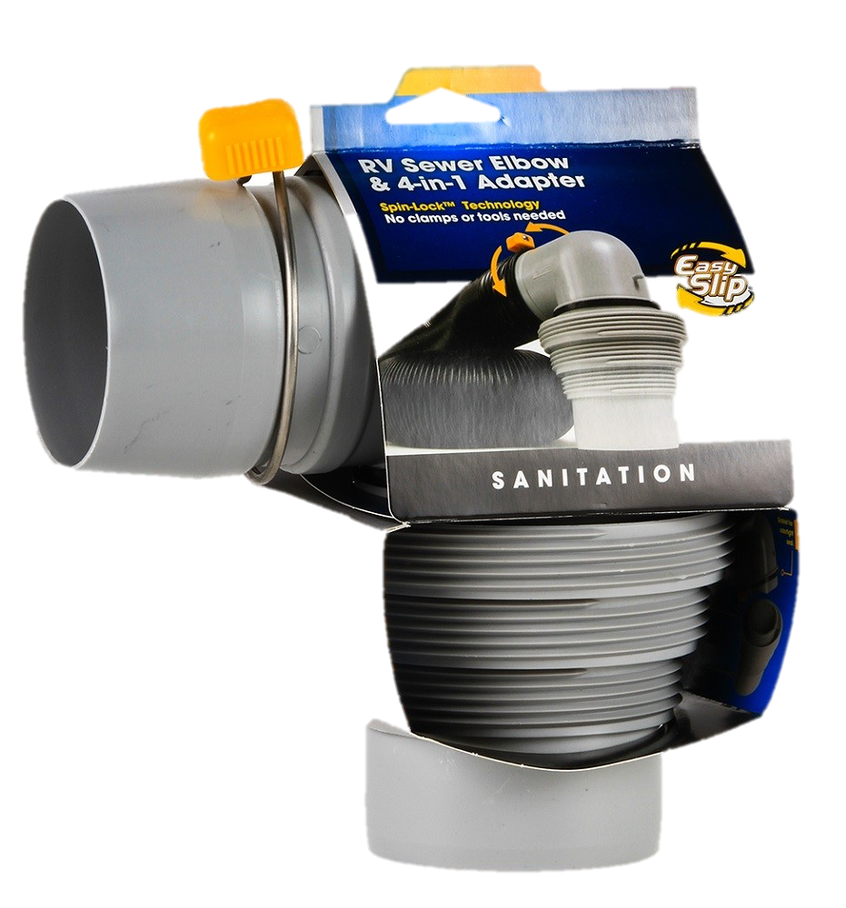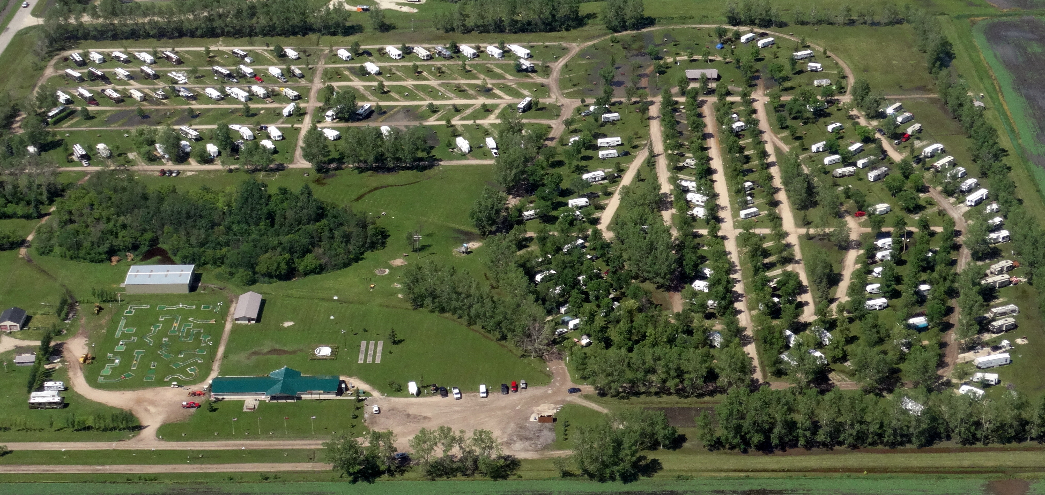

**FREE WIFI / NO PASSWORD**

**!-Before You-!   
!-Dump-!**

**Do you have one of these?**

**At Town & Country Campground, it is mandatory for any unit wanting to use our sewer service to use an RV Sewer Adapter/Elbow.**

**If you do not have one, we have them available for purchase in the store.**

*\*These adapters help keep sewer gasses from escaping when in-use and more importantly, prevent accidental sewage spills. There is a $6,000 fine in Manitoba for raw sewage spills if you are caught. In addition, we have had several instances where campers not using elbow adapters have lost their entire sewer hoses down the sewer pipe which not only could cause pipe clogs and sewer back-up, it also causes immense damage to our sewage pumps and filters.*

**ATTENTION:   
Campers with 50-amp RVs who voluntarily request 30-amp sites**

**If your RV requires 50 amp service, but you have specifically requested a 30 amp site, please be advised that in the event you exceed the capacity of the 30 amp service and require our breaker to be reset to restore your power, you will be required to pay the difference to use 50 amp service in addition to a $10 service fee.**

Welcome to

Town & Country

Campground!

Alcoholic Beverages

* Alcohol may only be consumed on a registered campsite.
* Alcohol is not permitted in day-use or public areas including picnic shelters, mini golf course and playground.

Pets

* Pets must be kept leashed and attended at all times in the campground.
* Pet owners must ensure that pet litter is cleaned up immediately, both on roads/walkways and campsites. We are a pet-friendly campground but have zero-tolerance for pet litter not being cleaned up. Please be considerate of your fellow campers and the campers to use your site after you leave and ensure you nothing behind. Failure to clean up after your pet could result in eviction without refund.
* Pets are not permitted on/in public structures (playground, bathrooms, and showers)
* Please keep pets quiet and ensure they do not become a nuisance, danger or threat to the comfort and safety of your fellow campers.

Garbage

* Large garbage bins can be found in the parking lot adjacent to the main office as well as on the north side of the campground on Comfort Blvd. near the bathroom and shower facilities on Chipmunk Circle.
* Please dispose of your garbage daily, directly into the bin and do not leave your garbage outside for extended periods of time as it attracts birds and other wildlife.
* Garbage bins are monitored 24/7 via CCTV and are for your personal garbage only. Please do not dispose of any commercial/business garbage such as wood, scrap metal, tools, machinery, chemicals, oil, paint etc… in our bins. Failure to comply could result in eviction without refund.

Refund Policy

Things happen, circumstances arise, we understand that completely! The following is our policy on stays that are unexpectedly cut short:

* If you have paid the nightly rate, any remaining nights will be kept on-file as a camping credit
* If you have paid the weekly rate, your stay will be re-calculated at the daily rate and you will be refunded the difference from what you originally paid
* If you have paid the monthly rate, your stay will be re-calculated at the weekly rate and you will be refunded the difference from what you originally paid
* If you have paid the seasonal rate, your stay will be re-calculated at the monthly rate and you will be refunded the difference from what you originally paid

**Rules & Regulations**

**Thank you for choosing to stay with us! We sincerely hope you enjoy your stay; whether you’re for a day, week, month or season!**

**To help ensure everyone has a great and safe time here, we ask that you please take a moment and read over our rules and regulations in this brief booklet**

•Quick Reference•

**Check-in:**

**2:00pm**

**Check-out:**

**12:00pm**

**Quiet Time:**

**11:00pm – 8:00am**

**Campground Speed Limit:**

**20km/h**

**Playground Zone:**

**5km/h**

**Current Office Hours:**

**Mon-Sun 0900 – 1700**

**Mini Golf & Arcades  
Mini Golf $1/pp**

**Children under 12 must be accompanied by an adult   
Billiards  
Children under 16 must be accompanied by an adult**

**AFTER HOURS LINE**

**204-558-4883**

Campsites

* All campers must register for their site at the registration office **prior** to setting up camp.
* Campsite registrant must be at least 18 years of age.
* All camping units (other than tents) and vehicles, must be legally registered and display a current, valid license plate at all times while in the campground.
* A limit of six (6) people per campsite is allowed for non-immediate family groups. “Immediate” is defined as a family consisting of a parent and children 18 years of age and under or another adult acting in a guardianship role of said children in the absence of parent(s).
* The registrant is responsible for the conduct and behavior of their family and guests.
* Quiet time is from 11:00pm to 8:00am. All radios, musical instruments, and other audio equipment are to be turned off during quiet time so as to not disturb other campers.
* Campfires are only allowed in the fire pits provided at each campsite. **Fire pits are not to be moved from its current spot on the site.** Doing so will result in a site damage fee of $50.

Camping Equipment

* Only one camping unit (tent, tent trailer, camper, camper-truck/van, camping trailer or motorhome) permitted on each campsite. Mobile homes, bunkhouse and school-bus-type RVs are not permitted.
* No generators are permitted to be used at campsites.
* **Please do not dump anything other than gray and black water down our sewers i.e. do not dump rubber gloves, inanimate objects (toys, candles, toothbrushes etc…) into our sewage pipes as our septic system is sensitive and anything other than liquids and toilet paper threaten to clog our pumps which could cause a catastrophic septic back-up.**
* Campers are permitted one (1) vehicle at their site. Extra vehicle(s) must be registered at the office and parked in the additional vehicle parking areas.
* One small tent for accommodating dependent children and one screened tent for meal purposes is permitted depending on the size of the campsite and length of stay. Additional small tents for dependent children may be allowed at the discretion of campground management.
* Patio lights/string lights/outdoor lights are permitted, however must be turned off by quiet time out of courtesy to your neighbours who may be trying to sleep!

Campsite Visitors

* If you are expecting a visitor during your stay, in the interest of your safety and security, please advise the office and provide your visitor’s name so we know it is ok to send them to your site.
* All visitors must register at the office upon arrival *vehicle plate number will be required at time of visitor registration
* Visitors are not permitted to enter the park after quiet time has taken effect.

A little more detail…

* The speed limit in the park is a **maximum of 15km/h, and 5km/h when driving near the playground.** At any given moment, a child could run out of a campsite or playground right into the street without notice. Please obey traffic signs and posted speed limits and be constantly aware of campers taking a stroll, walking their dogs, and children at play. At Town & Country Campground, the safety of our campers is our number one priority and we do not tolerate speeding. A Two-Strike rule is in effect – if you are caught speeding, you will get your first and only warning. If you are caught a second time, you will immediately be evicted from your site with no refund.
* Check out is noon (12:00pm). If you need a little extra time, please advise the office ahead of time – Late check-out is charged at $3/hr.
* Garbage bins are located in the parking lot adjacent to the main office and at the end of Racoon Blvd in Chipmunk Circle.
* The registrant, their family and visitors shall comply at all times with all rules and regulations. The registrant is responsible for the conduct and behavior of their family and visitors. Rowdy behavior or excessive noise is not permitted nor tolerated at any time. Please be mindful and considerate of your neighbours!
* Only **one** registered vehicle is permitted to park on your campsite. Any additional vehicles must register with the office and parked in the designated parking areas. **Please do not take the liberty of parking in empty campsites.**
* Fire pits are provided at each campsite; Pallet-burning is prohibited, firewood is available onsite in the main office. The removal or destruction of natural objects is also prohibited, including plants, trees and shrubs.
* Large mats are permitted, providing you are using a breathable RVing mat
* Use of fireworks by campers are prohibited
* RV/vehicle-washing is not permitted. If you are in dire need of a wash, please give the office a call and they would be happy to provide you with contact information to RV/car washes in the area.
* Clotheslines are prohibited in the interest of our grounds keeping staff’s safety when cutting grass on campsites as well as the safety of other campers
* No smoking in any campground buildings to include the office, Laundromats, game room or bathrooms/showers.
* Every person using a campsite or other facility in the campground area shall maintain it in a clean and sanitary condition at all times.
* In its sole discretion, Town & Country Campground reserves the right to refuse service, or revoke your camping privileges should you, your family or your visitors fail to comply with any of these rules. By utilizing the campground and its services you hereby consent to the same.